16 July – 2024

Day 6

8 Creating job to build react js project.

To create react js project node js must present

node --version

npx create-react-app react-with-jenkin

or

npm install react-react-app -g

create-react-app react-with-jenkin

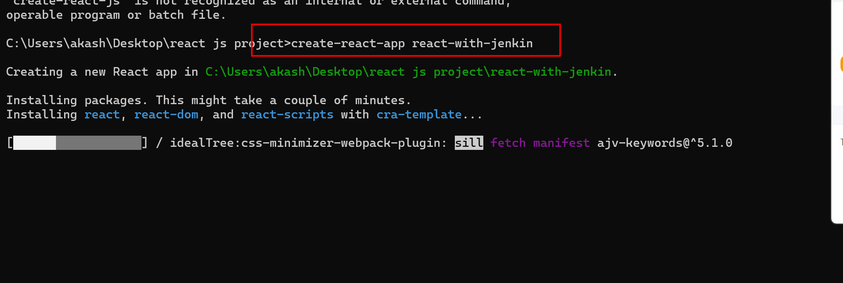

Do some changes in App.js file and using npm start command please test your project.

Please push this project from local machine to your remote repository

git init

git add .

git commit -m “simple react project ready”

your code is push file os file system to local repository

please create remote repository in your git hub account and link that repository

with your local repository and push your project from local to remote repository.

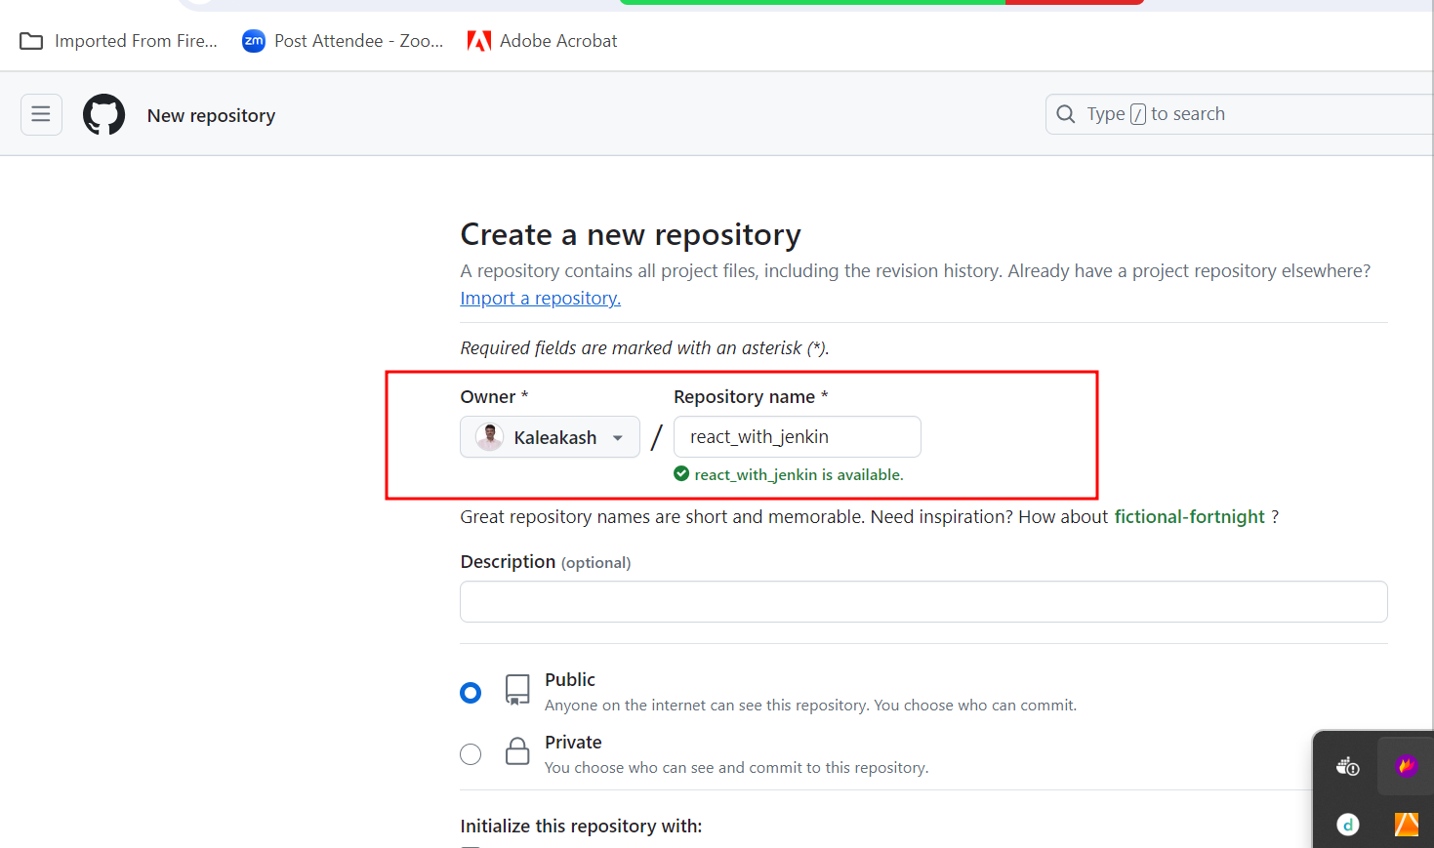

**Below command connect my local repository code with remote repository**

**git remote add origin https://github.com/Kaleakash/react_with_jenkin.git**

**Now we can’t push this code to remote repository**

**If you are not able to push the code successfully because of some reason. We will use token to push the code**

**Already local machine connected with remote machine using URL and that URL store in origin keyword.**

**git remote rm origin this command is use to remove origin or**

**link with remote repository**

**Now we will generate token.**

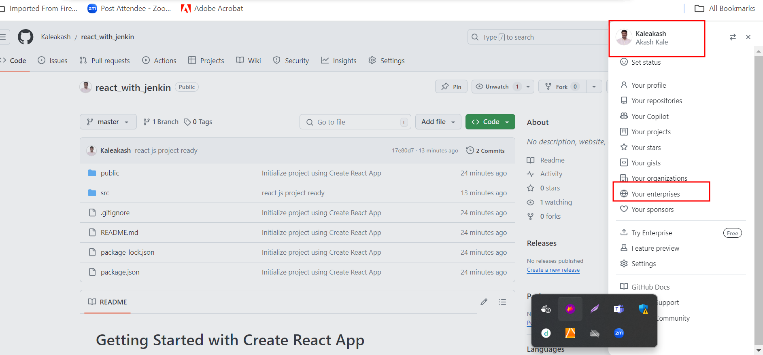

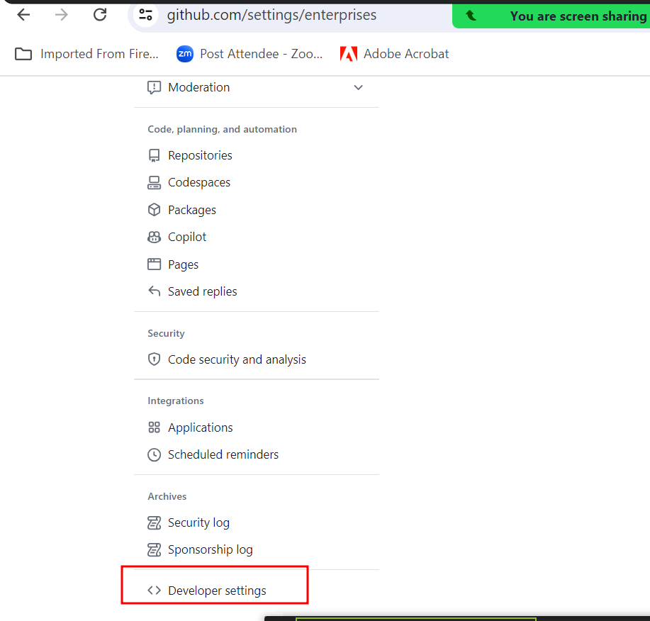

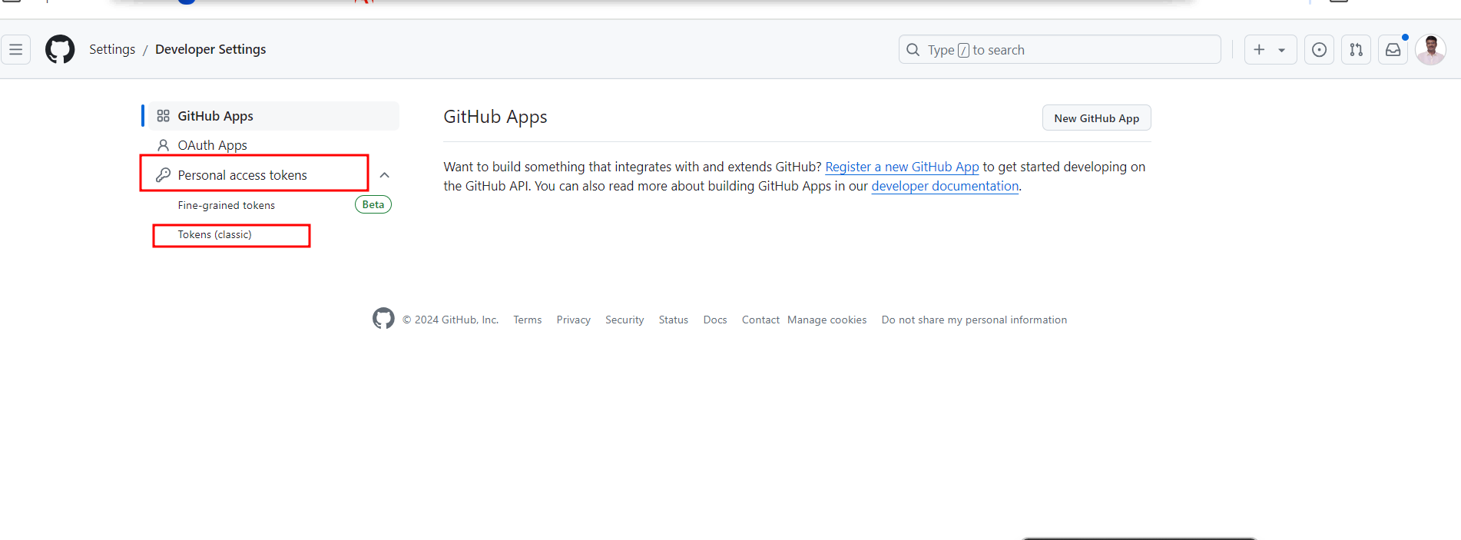

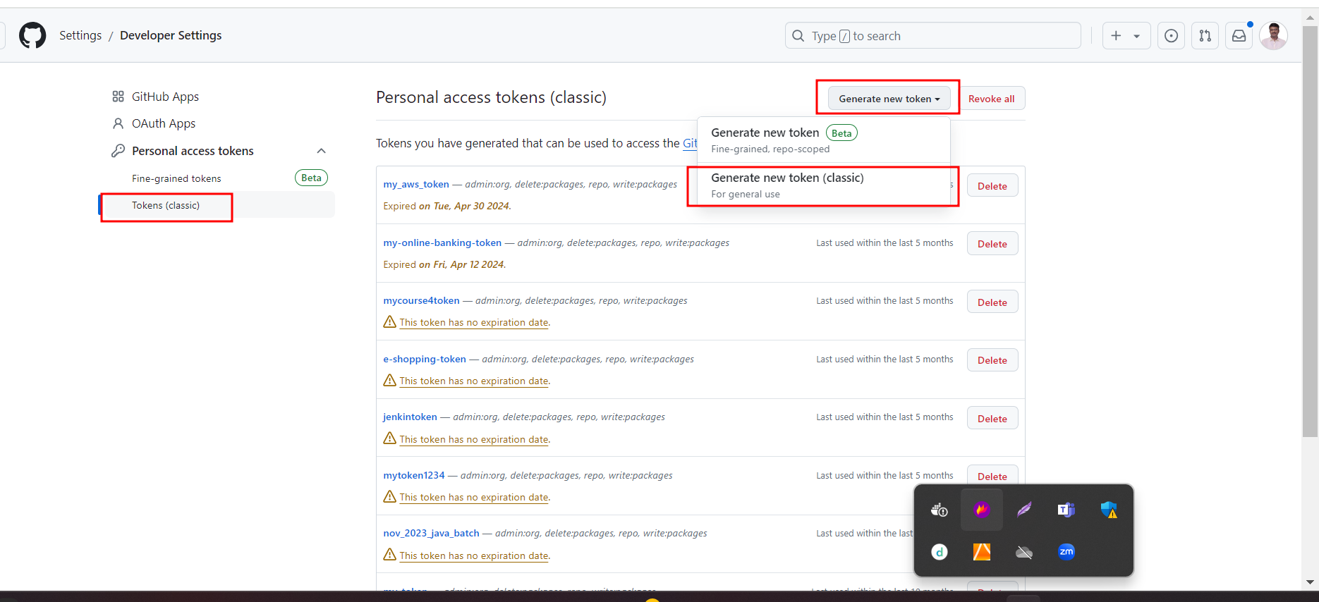

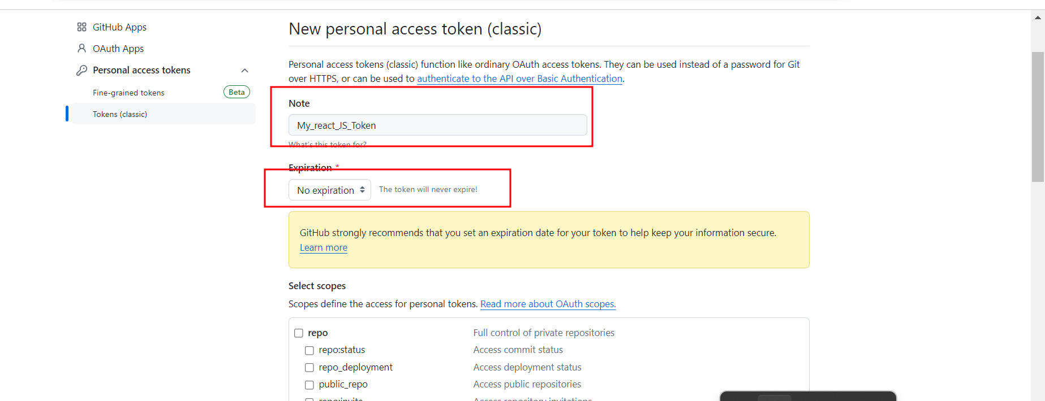

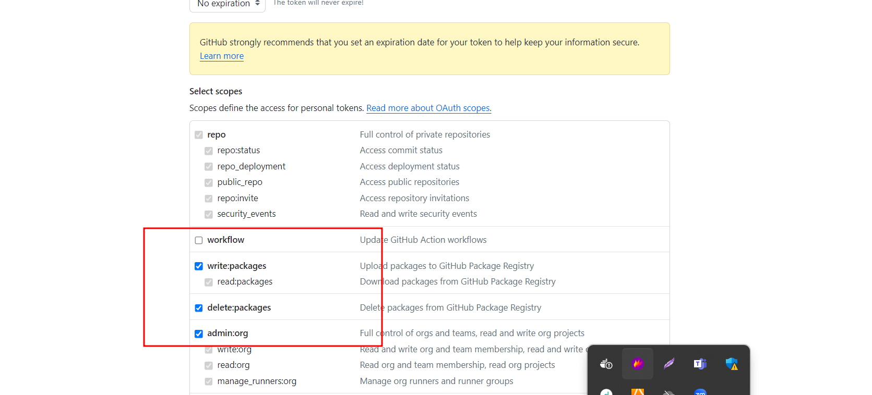

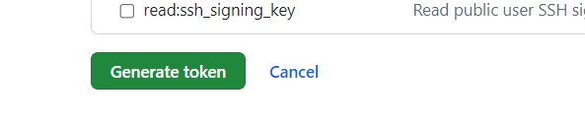

**Copy the token**

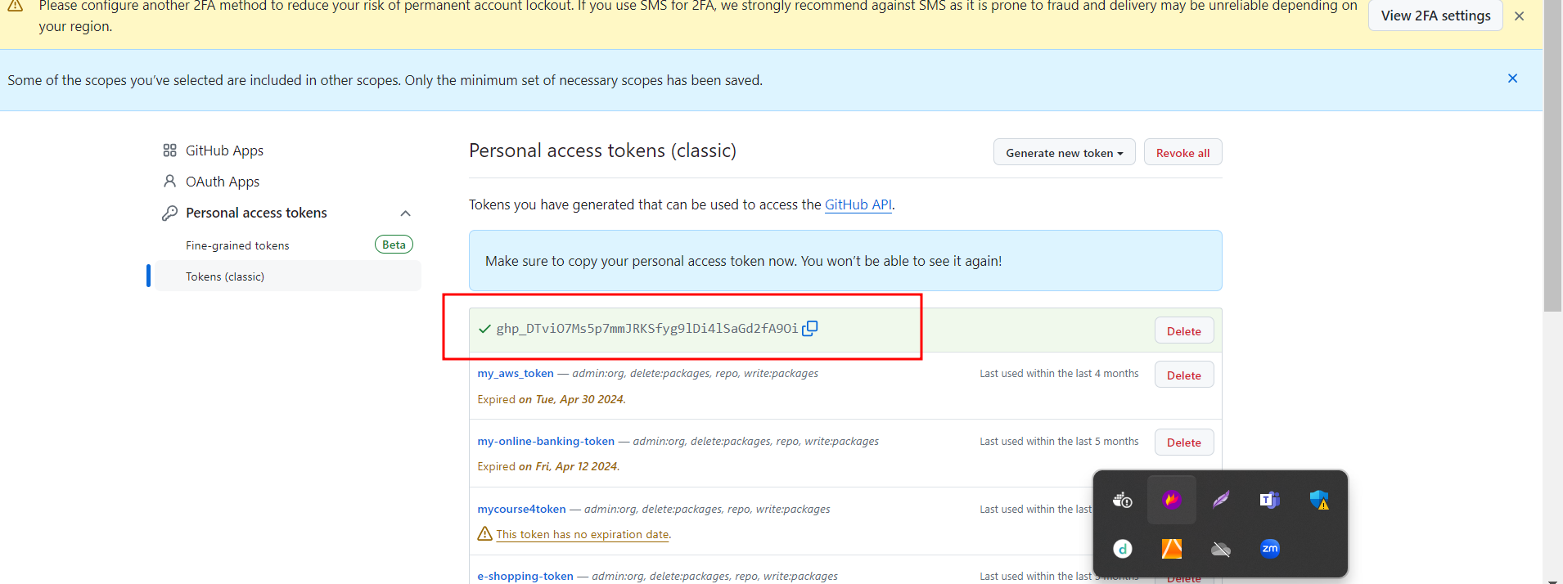

**git remote add origin https://ghp\[email]/Kaleakash/react_with_jenkin.git**

**git push -u origin HEAD**

Creating Jenkin job to build react js project.

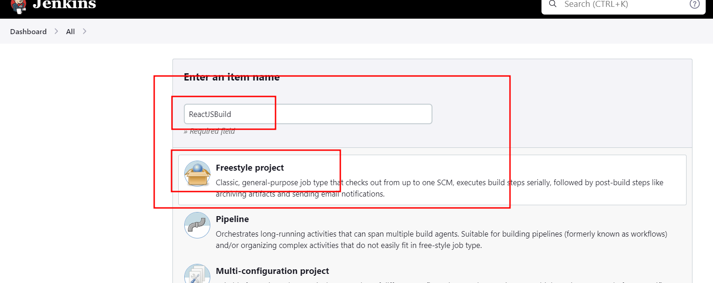

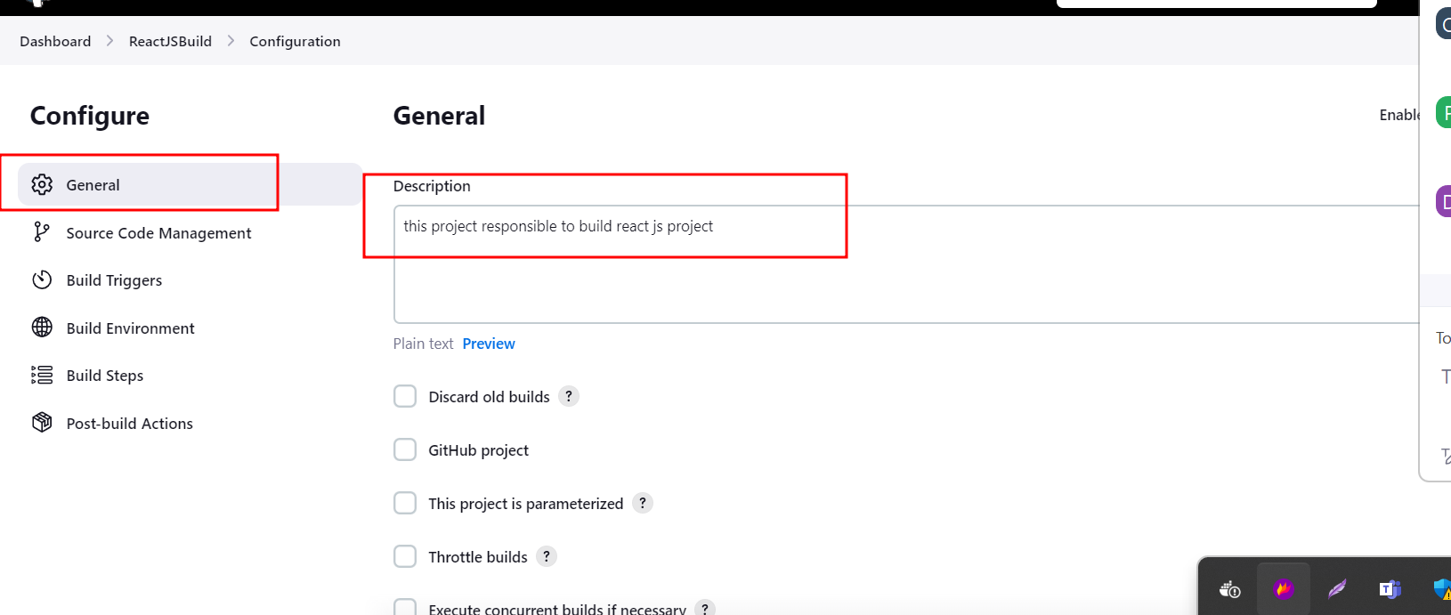

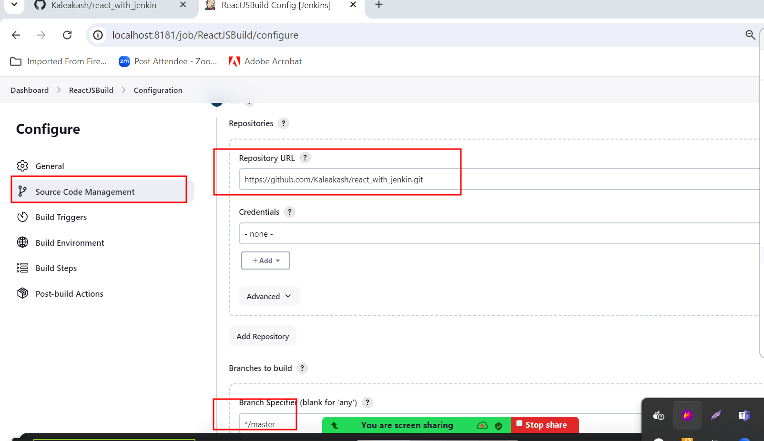

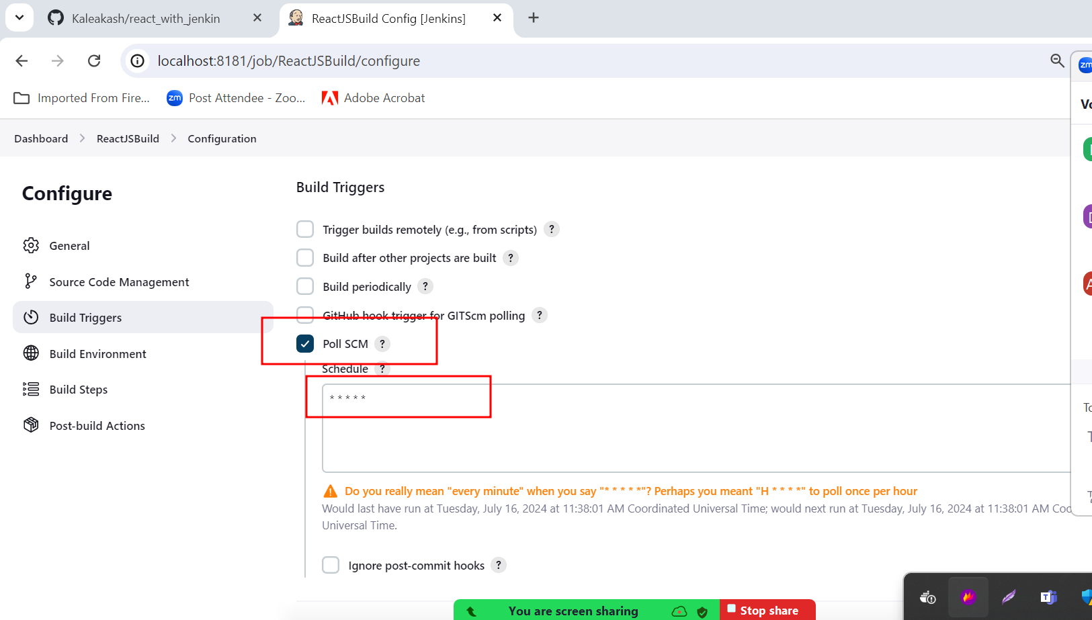

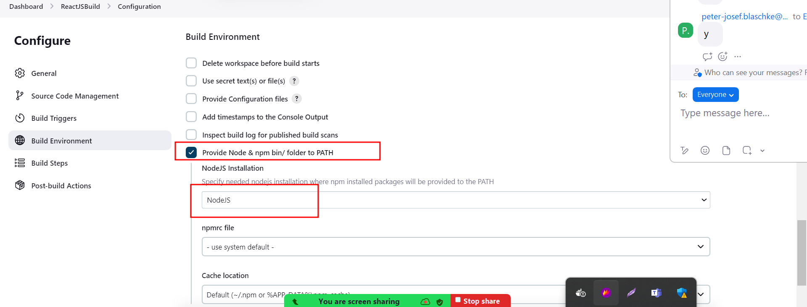

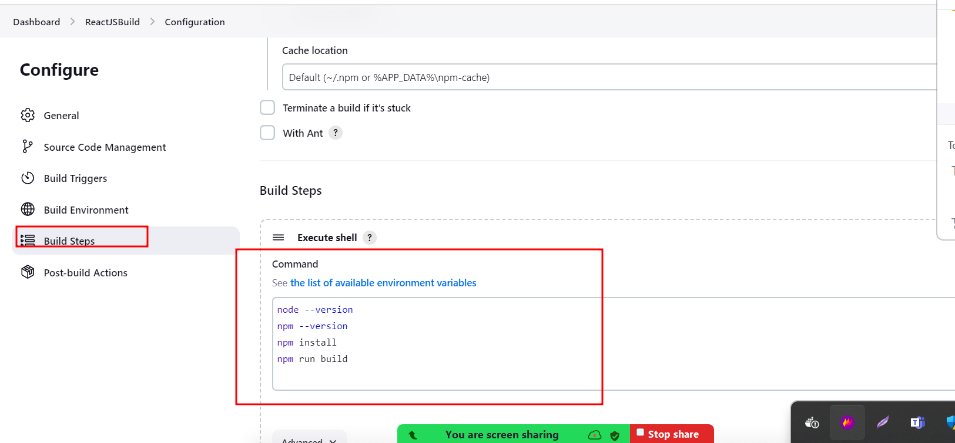

Click on apply and save

Then build the project

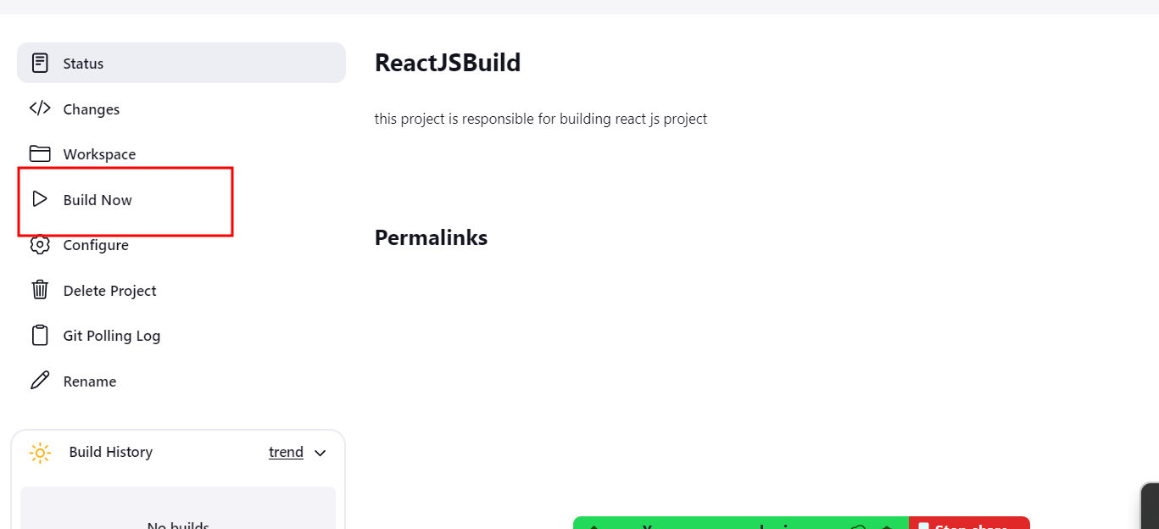

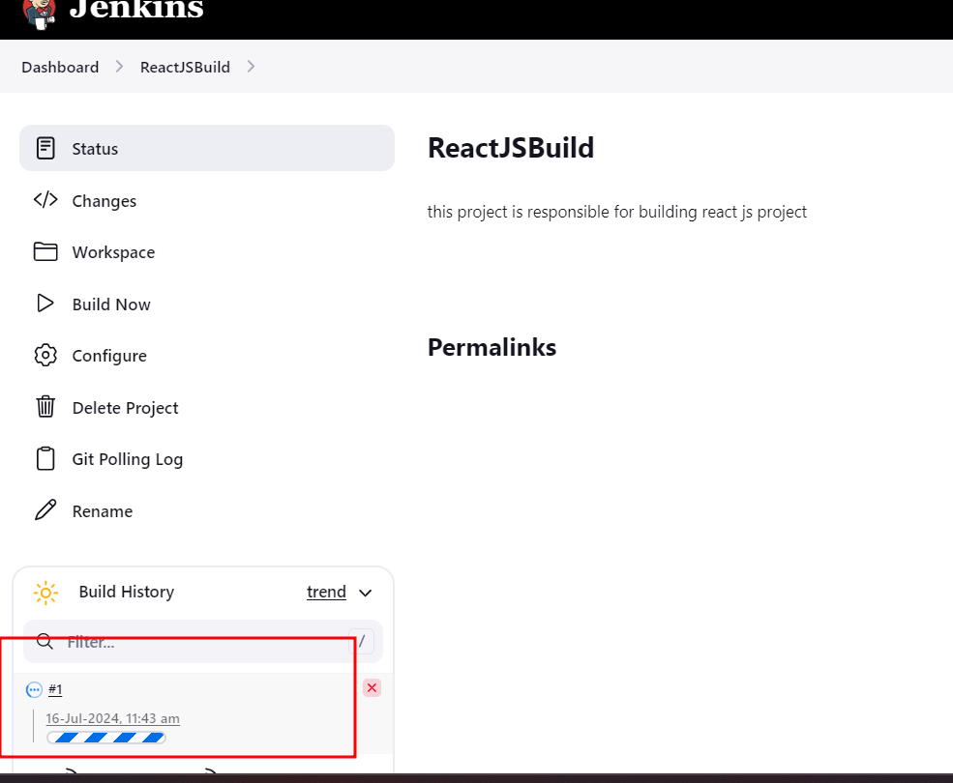

If fail and if you are running CI and CD tool using Docker images please write below

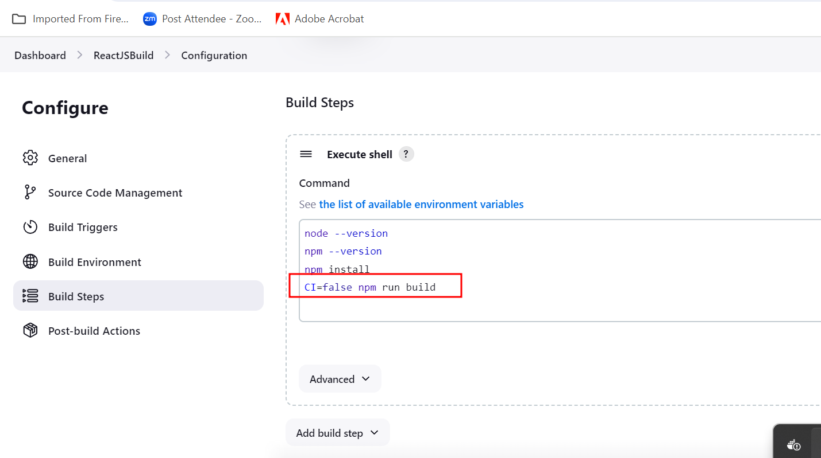

Jenkin Pipeline Or CI/CD pipeline : CI and CD pipe line which is responsible to execute set of event or jobs which interconnected with each others.

Creating simple CI and CD pipe line jobs.

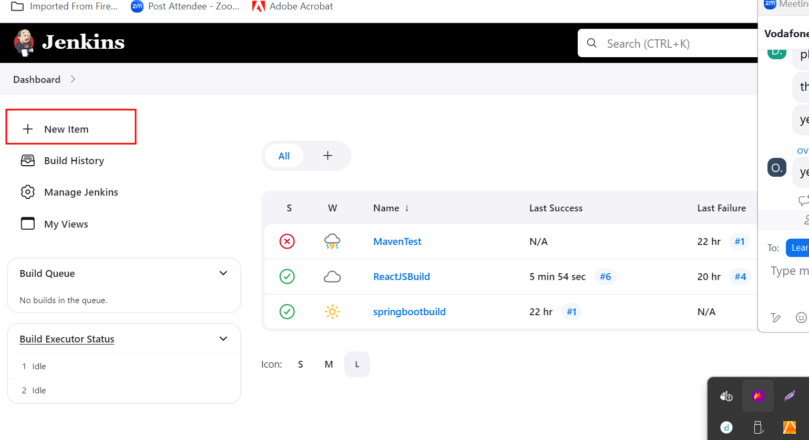

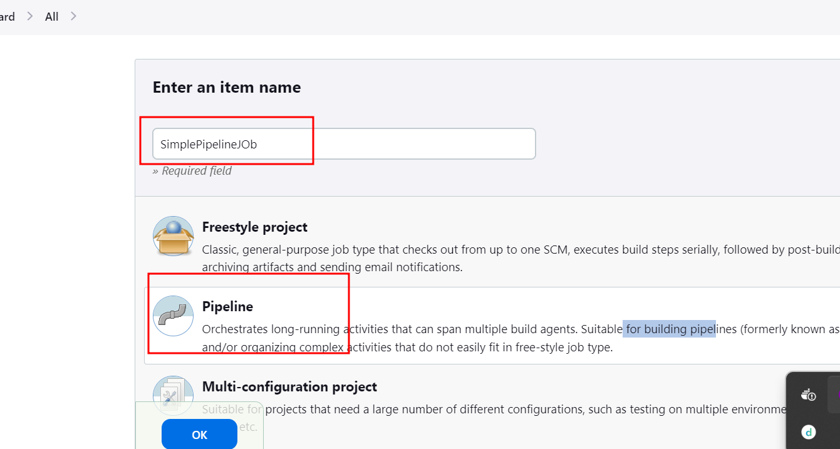

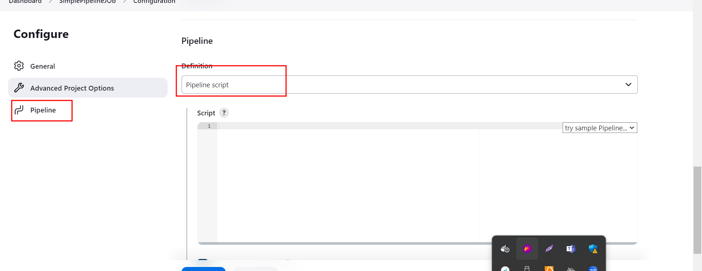

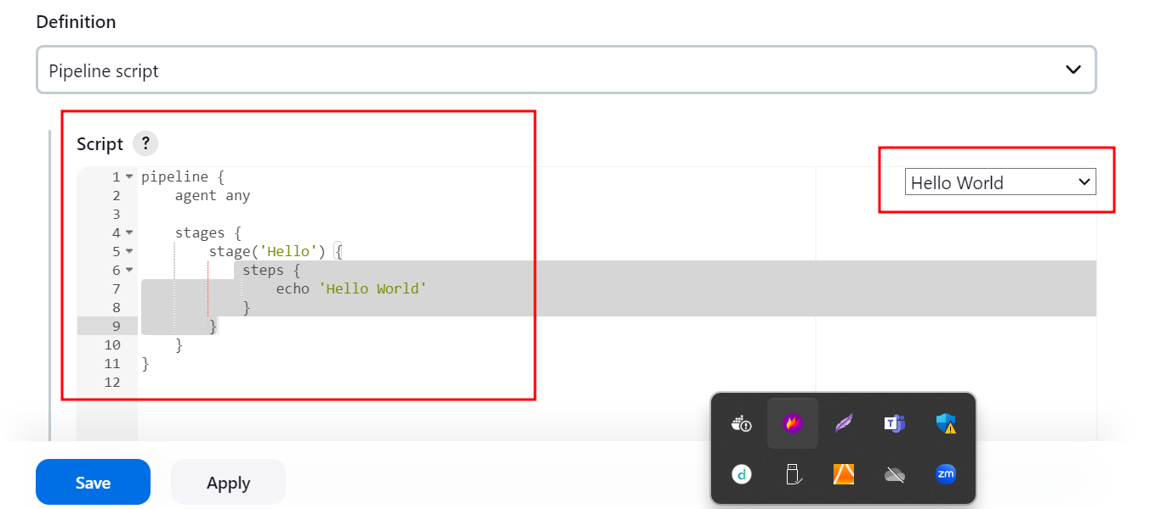

Apply and save then build it.

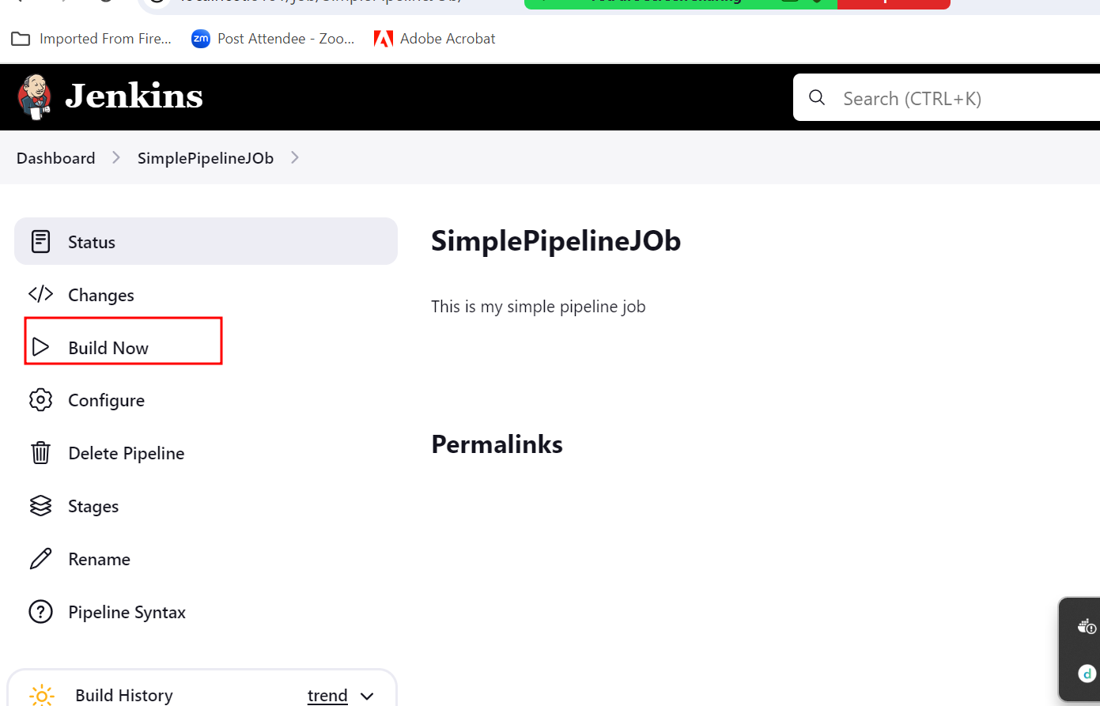

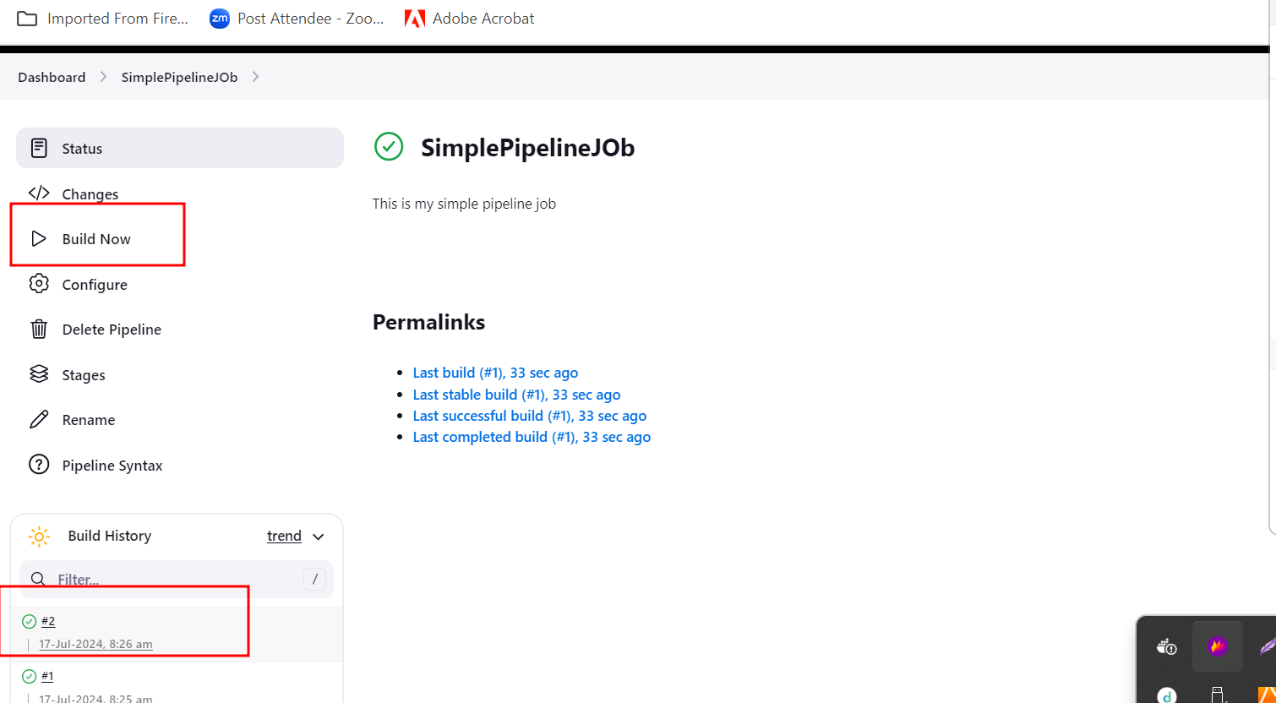

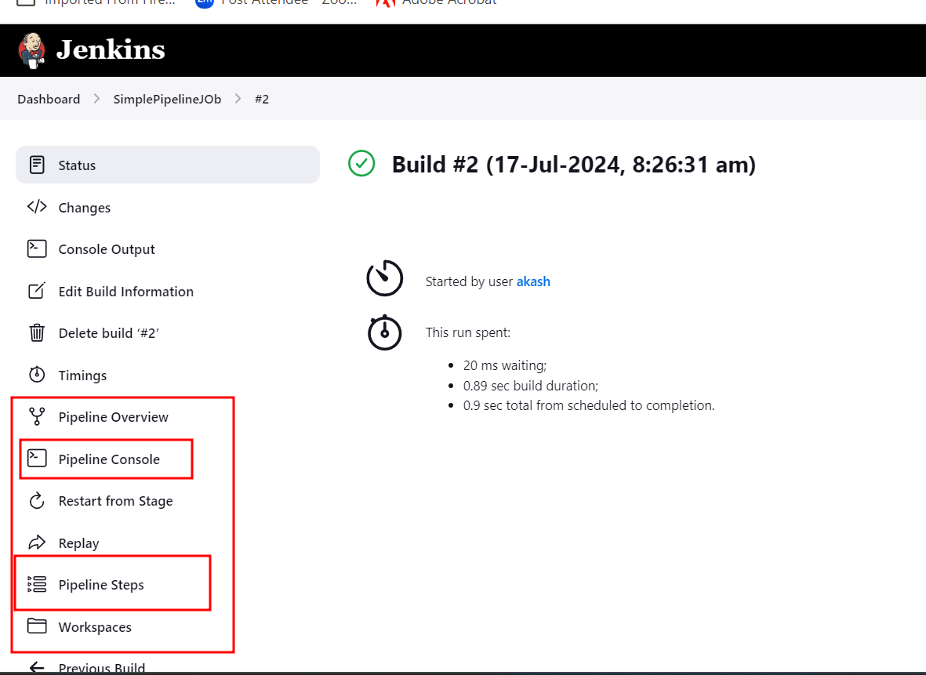

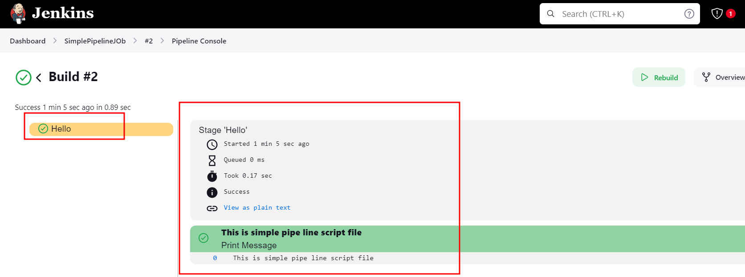

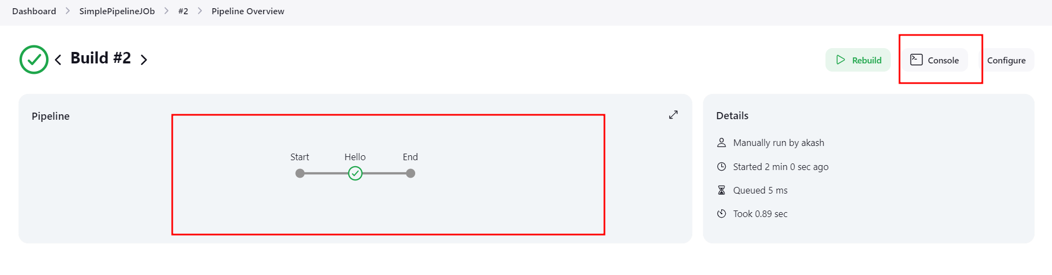

Another pipe line job with customer script file.

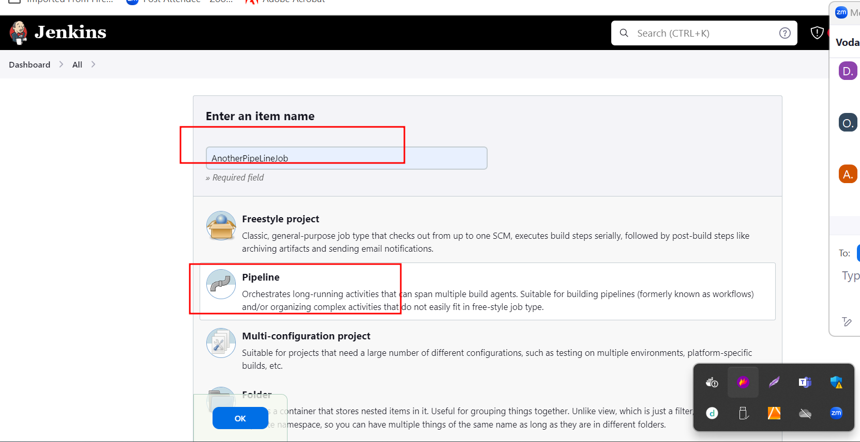

Sample script file

pipeline {

agent any

stages {

stage('Checking the version of all software') {

steps {

echo 'Check all version of software'

sh 'java --version'

}

}

stage('Compile all program') {

steps {

echo 'All program compiled'

}

}

stage('Creating jar or war or build file') {

steps {

echo 'creating jar or war files'

}

}

stage('Test the project') {

steps {

echo 'Testing the project'

}

}

}

}